**JWST MAGIC: User’s Guide**

**The Multi-Application Guiding Interface for Commissioning**

Last updated: February 28, 2019

POC: Lauren Chambers ([lchambers@stsci.edu)](mailto:lchambers@stsci.edu)) or Keira Brooks ([kbrooks@stsci.edu](mailto:kbrooks@stsci.edu))

*Special notes for users:*

* If something is not working as is stated in this guide, please submit an issue on <https://grit.stsci.edu/wfsc/tools> (accessible from WFSC Guiding console – make sure you log in as yourself using your AD username and password) using the “Issues” button on the left-hand side of the page. Please specify that it is for this tool and be specific about the problem that you ran into.
* If the issue you are having is preventing you from completing your task, immediately contact Keira Brooks ([kbrooks@stsci.edu](mailto:kbrooks@stsci.edu), x6821) or Lauren Chambers ([lchambers@stsci.edu](mailto:lchambers@stsci.edu), x6517).

______________________________________________________________________________

**Table of Contents**

1. Introduction
2. Setting Up
3. Determining and Loading the Input Image
4. Selecting Guide & Reference Stars for an Input Image and Writing Files
5. Testing Selections in DHAS
6. Contingency: Re-selecting Stars and Re-running DHAS
7. Writing the Segment Override File
8. Writing the Photometry Override File

**Appendices**

1. Installing the JWST MAGIC Package
2. Opening DHAS
3. Using APT to Get Guide Star RA & Dec
4. Mirror State Procedures

# Introduction

MAGIC is the Multi-Application Guiding Interface for Commissioning. It is a set of tools written in Python that allows the user to co

The Multi-Application Guiding Interface for Commissioning (MAGIC) is a Python package that provides convenient access to a set of tools that will be used, as the name suggests, with the JWST FGS during OTE Commissioning. The package allows for user interaction with commissioning data and creates files that are needed for the operation of the flight software and the execution of visits.

These tools comprise of four main components that can be run individually

or together:

## NIRCam to FGS image conversion (Image Converter)

This tool can take in a simulated (or real) NIRCam image and will convert

it to an FGS (guider 1 or guider 2) image. In addition to rotating the image,

adjusting the pixel scale and image size, this tool corrects bad pixels and

normalizes the image to a specific magnitude of star.

## Star Selection Tool (Star Selector)

This tool will take the FGS image either created with the first tool, or

an FGS image that it is passed by the user, and allow the user to choose

the guide star and reference stars using a GUI.

## Flight Software File Writer (Flight Software (FSW) File Writer)

This module requires an FGS image and a file that includes a list of the

coordinates of the guide star and reference stars, along with their count

rates. This tool will create all files necessary to test this image different

flight software simulators (FGS DHAS, FGSES, etc.) These include all the

files necessary to run the ID, ACQ1, ACQ2, and TRK steps in these simulators.

## Segment Guiding Tool (Segment Guiding)

Used to facilitate guiding on unstacked segment arrays during commissioning. When

provided 1) the commanded RA and Dec of a guide star and 2) the V2/V3 (or x/y)

positions of all segments in an array, the segment guiding tool calculates the

effective RA and Dec of all segments on the sky.

This document will walk you through how to use each of the parts of MAGIC and verify those results. Note: A powerful feature of MAGIC is that is retains information about the image you are working on as long as the window stays open and the file is loaded, so we recommend that while working with MAGIC, you keep the GUI open. If it crashes (which can happen) don’t worry, just following section II again and use the same input values and MAGIC will find the dataset that you are using.

**“We’re not really going to use magic?” – Ronald Weasley**

# Setting Up

1. If you have not yet installed the tools, go to Appendix A.
2. Check that you are in your astroconda environment.
3. Make sure that you have the most up-to-date version of the tools (pull the most recent version of the tools from the repo):

$ cd /Users/<username>/tools

$ git pull origin master

# Determining and Loading the Input Image

MAGIC takes in any FGS image or a NIRCam image that was taken with the CLEAR filter (the NIRCam weak lens (WL) filter will cause MAGIC to crash). If you want MAGIC to convert this image into a raw dectector FGS image, you can indicate this by checking the “Convert Image” check box. In most cases MAGIC can determine from the header information which instrument and detector the image is from, however if it can’t figure this out from header information, you will have to help it out by telling it which instrument and detector your input image comes from. You can also renormalize and/or add background images to your seed image.

1. From your astroconda environment, start an IPython session and launch the main GUI:

$ ipython

In [1]: import jwst_magic

In [2]: jwst_magic.run_tool_GUI()

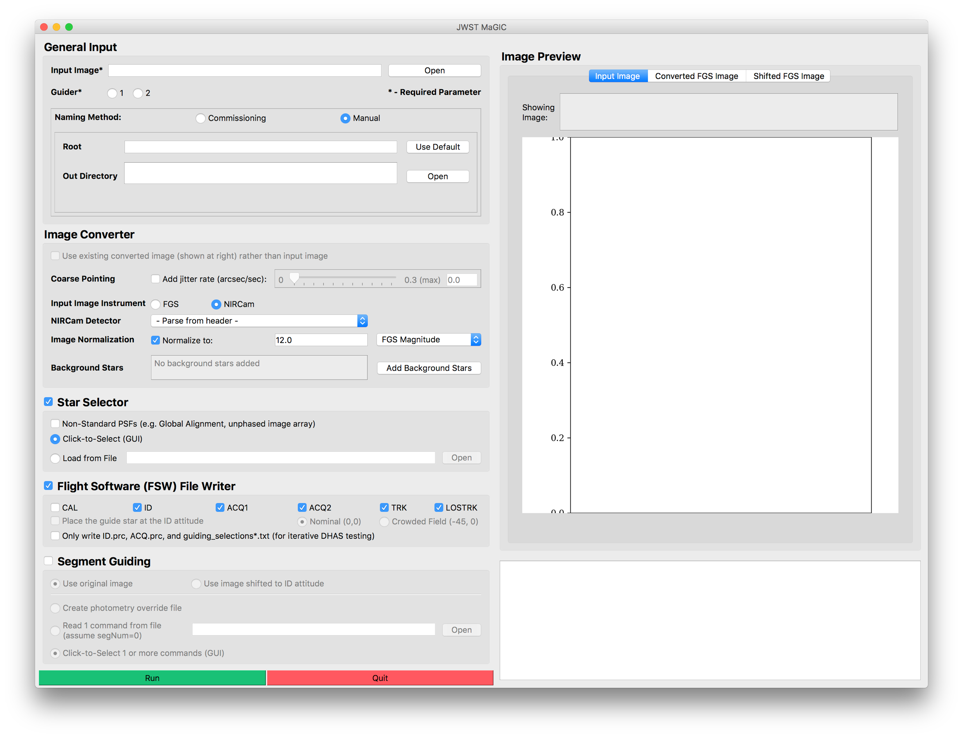

Figure - Main GUI for the JWST MAGIC Tool

1. Set general input parameters:



**B**

**A**

Figure - General Input section of the Main GUI

* 1. **Load the input image** **A**  A preview of the image and the full path to the image will appear in the Image Preview box at right.
  2. **Specify the guider** **B**  This is the guider that the final image should simulate. If this is not known, check the APT file (see Appendix B for more information about using APT).

1. If you are running MAGIC on the SOGS network to generate files for commissioning:
   1. **Check the “Commissioning” radio button** **C**  to set the naming method.

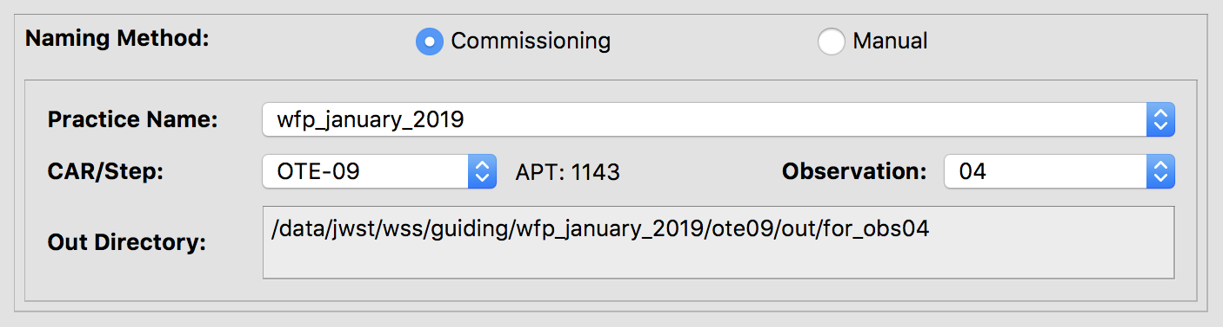

**E**

**F**

**D**

**C**

Figure – Commissioning naming parameter section of the main GUI

* 1. **Select the practice name** **D**  corresponding to the current activity.
  2. **Select the CAR or step name**  **E**  of the activity you are generating an override file for.
  3. **Select the observation number** **F**  of the activity you are generating an override file for.

Considering these parameters all together, the output files will be saved in the /data/jwst/jwss/guiding/{practice}/{car}/out/for_obs{obs}/ directory,

with the root for_obs{obs}_G{guider}.

1. If you are running MAGIC off of SOGS, or to generate test data:
   1. **Check the “Manual” radio button** **G**  to set the naming method.

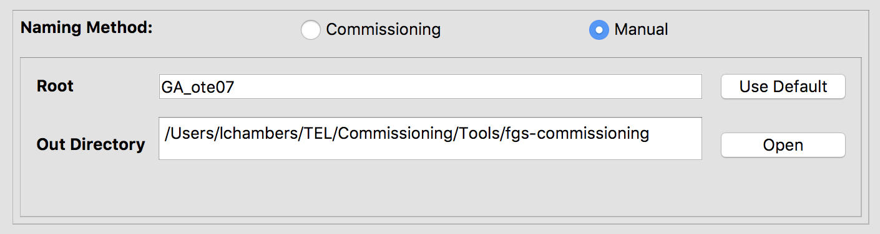

**I**

**H**

**G**

Figure – Manual naming parameter section of the main GUI

* 1. **Specify a root name** **H**  If different than the default name that was created when the input image was uploaded. The root will be used to to create the output directory where all created files will reside, out/{root}.
  2. **Change the out directory** **I**  Choose the location to where the files were copied in Part II. An out/ directory will be created in this location, and this is where all the files will be saved.

Considering these parameters all together, the output files will be saved in the {out}/out/{root}/ directory, with names of the format {root}_G{guider}....

1. Set image conversion parameters: (Note: The steps labelled “optional” below will create higher-fidelity simulations, but are not necessary when using MAGIC to generate FSW input or segment override files.)



**E**

**D**

**C**

**A**

**B**

Figure - Image Converter section of the Main GUI

* 1. (Optional) **Simulate the effects of coarse pointing** **A**  by specifying the jitter rate of the observatory. A jitter rate of 0.7 arcsec/sec creates images that are similar to ITM simulations in coarse point. Otherwise, ensure the “Add jitter rate” box is unchecked.
  2. Check that the **instrument** **B** **and NIRCam detector** **C** used to take the input image are set to the correct values; change them if not. (If the NIRCam detector is not defined, the tool will attempt to parse it from the input FITS header.) The FGS-formatted image will be saved to out/{root}/FGS_imgs/{input_image}_G{guider}.fits
  3. (Optional) You can specify the **magnitude or counts for the normalization** **D** of the final image. Otherwise, ensure the “Normalize to” box is unchecked.
  4. (Optional) **Add background stars** to the final image.
     1. Click “Add Background Stars”. **E** The background stars dialog box will appear:



**C**

**B**

**A**

Figure - Background stars dialog window

* + 1. Select which method you wish to use to add stars to the image: randomly, with a user-defined table, or with a Guide Star Catalog (GSC) 2.4.1 query.
       1. To add stars randomly:
          1. Select the **“Add Stars Randomly”** **A** checkbox.
          2. Input the number of stars you want to add to the image
          3. Specify the magnitude range that these additional stars will lie between (relative to the magnitude of the guide star)
       2. To add stars individually:
          1. Select the **“Define Stars to Add”** **B** checkbox.
          2. If you wish to load star locations and brightness from a file, indicate the location of that file.
          3. Otherwise, enter into the table the X position in pixels, the Y position in pixels, and the countrate in J Magnitude of each star you wish to add. Click the “Add Another Star” button to add another row to the table, or the “Delete Star” button to remove a row.
       3. To add stars using a web query from the Guide Star Catalog:
          1. Select the **“Query Stars from Guide Star Catalog 2.4.1”** **C** checkbox.
          2. Enter the RA and Dec of the guide star, being sure to specify if the RA units as either hours or degrees.
          3. Enter the position angle (roll angle) of the observatory.
          4. Click the “Query GSC” button to add the stars that are visible in the FOV of the selected guider.
    2. Click “Done” to save and apply these selections, or click “Cancel” to close the window without updating the background star selections.
    3. Verify that the indicator shows that thcorrect number of background stars have been added.

# Selecting Guide & Reference Stars for an Input Image and Writing Out Files

One of the main features of MAGIC is that it allows the user to determine the guide and reference stars for a specific scene. While during normal opterations this is determined by the Guide Star Selection System (GSSS), during commissioning the MAGIC user will determine which PSFs will be used for guiding and as reference stars. You can turn on this feature by selecting the “Star Selector” check box.

1. Set star selection parameters:



**B**

**A**

Figure - Star Selection section of the Main GUI

* 1. Ensure the “Star Selector” box is checked.
  2. Inspect the input image and **indicate if the PSFs are non-standard**. **A**  This flag alters the PSF-finding algorithm in the star selector tool to widen the smoothing filter for diffuse images in early commissioning stages when the telescope is unphased. If you are unsure if the PSFs are phased, consult the “Guiding Method” row in the [Guider Commissioning Summary Table](https://innerspace.stsci.edu/pages/viewpage.action?spaceKey=INSTEL&title=Guider+Commissioning+Summary+Table) on Innerspace.
  3. If desired, **load pre-selected guide and reference stars from a file** **B**  by selecting the “Load from File” option and selecting the desired input file. This file must include X/Y pixel coordinates and count rates in the form of a filepath to a regfile.txt or .incat file. Providing this will bypass using the Star Selection GUI to click-to-select the guide and reference stars.

1. Set file writer parameters:

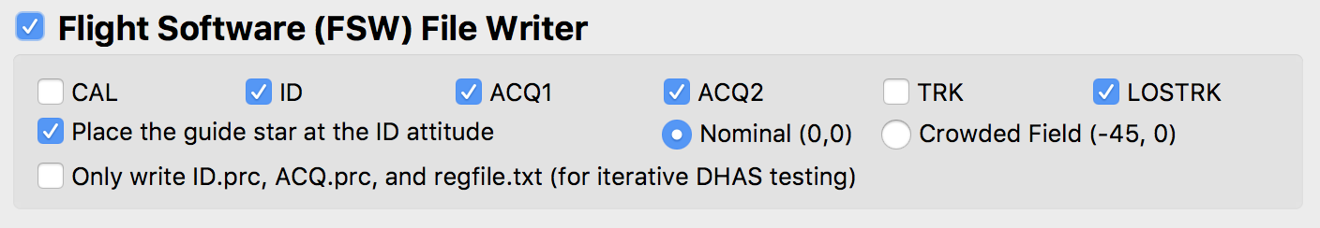

Figure - Flight Software file writer section for the Main GUI

1. Ensure the “Flight Software (FSW) File Writer” box is checked.
2. Check that all of the **necessary FGS steps** are selected.
   1. For general guiding, this includes all of the operational steps: ID, ACQ, and TRK. (These are the default selections.)
   2. For calibration observations, add the CAL step.
3. If you want to shift your image so that the selected guide star is moved to the center of the image, ensure the “Place the guide star at the ID attitude” box is checked. Designate whether the guiding field is crowded enough that the alternate ID attitude at (Ideal X, Ideal Y) = (-45, 0) should be used (“Crowded field”). Otherwise, leave the “Nominal” button selected such that the star is placed at (Ideal X, Ideal Y) = (0, 0).
4. Run the tool



1. Monitor the terminal window from which you launched the GUI to notice any possible errors that are raised.

*Note:* The output that appears in the command line is also written to:

/data/jwst/wss/guiding/MAGIC_logs/

1. When the Star Selection GUI appears:

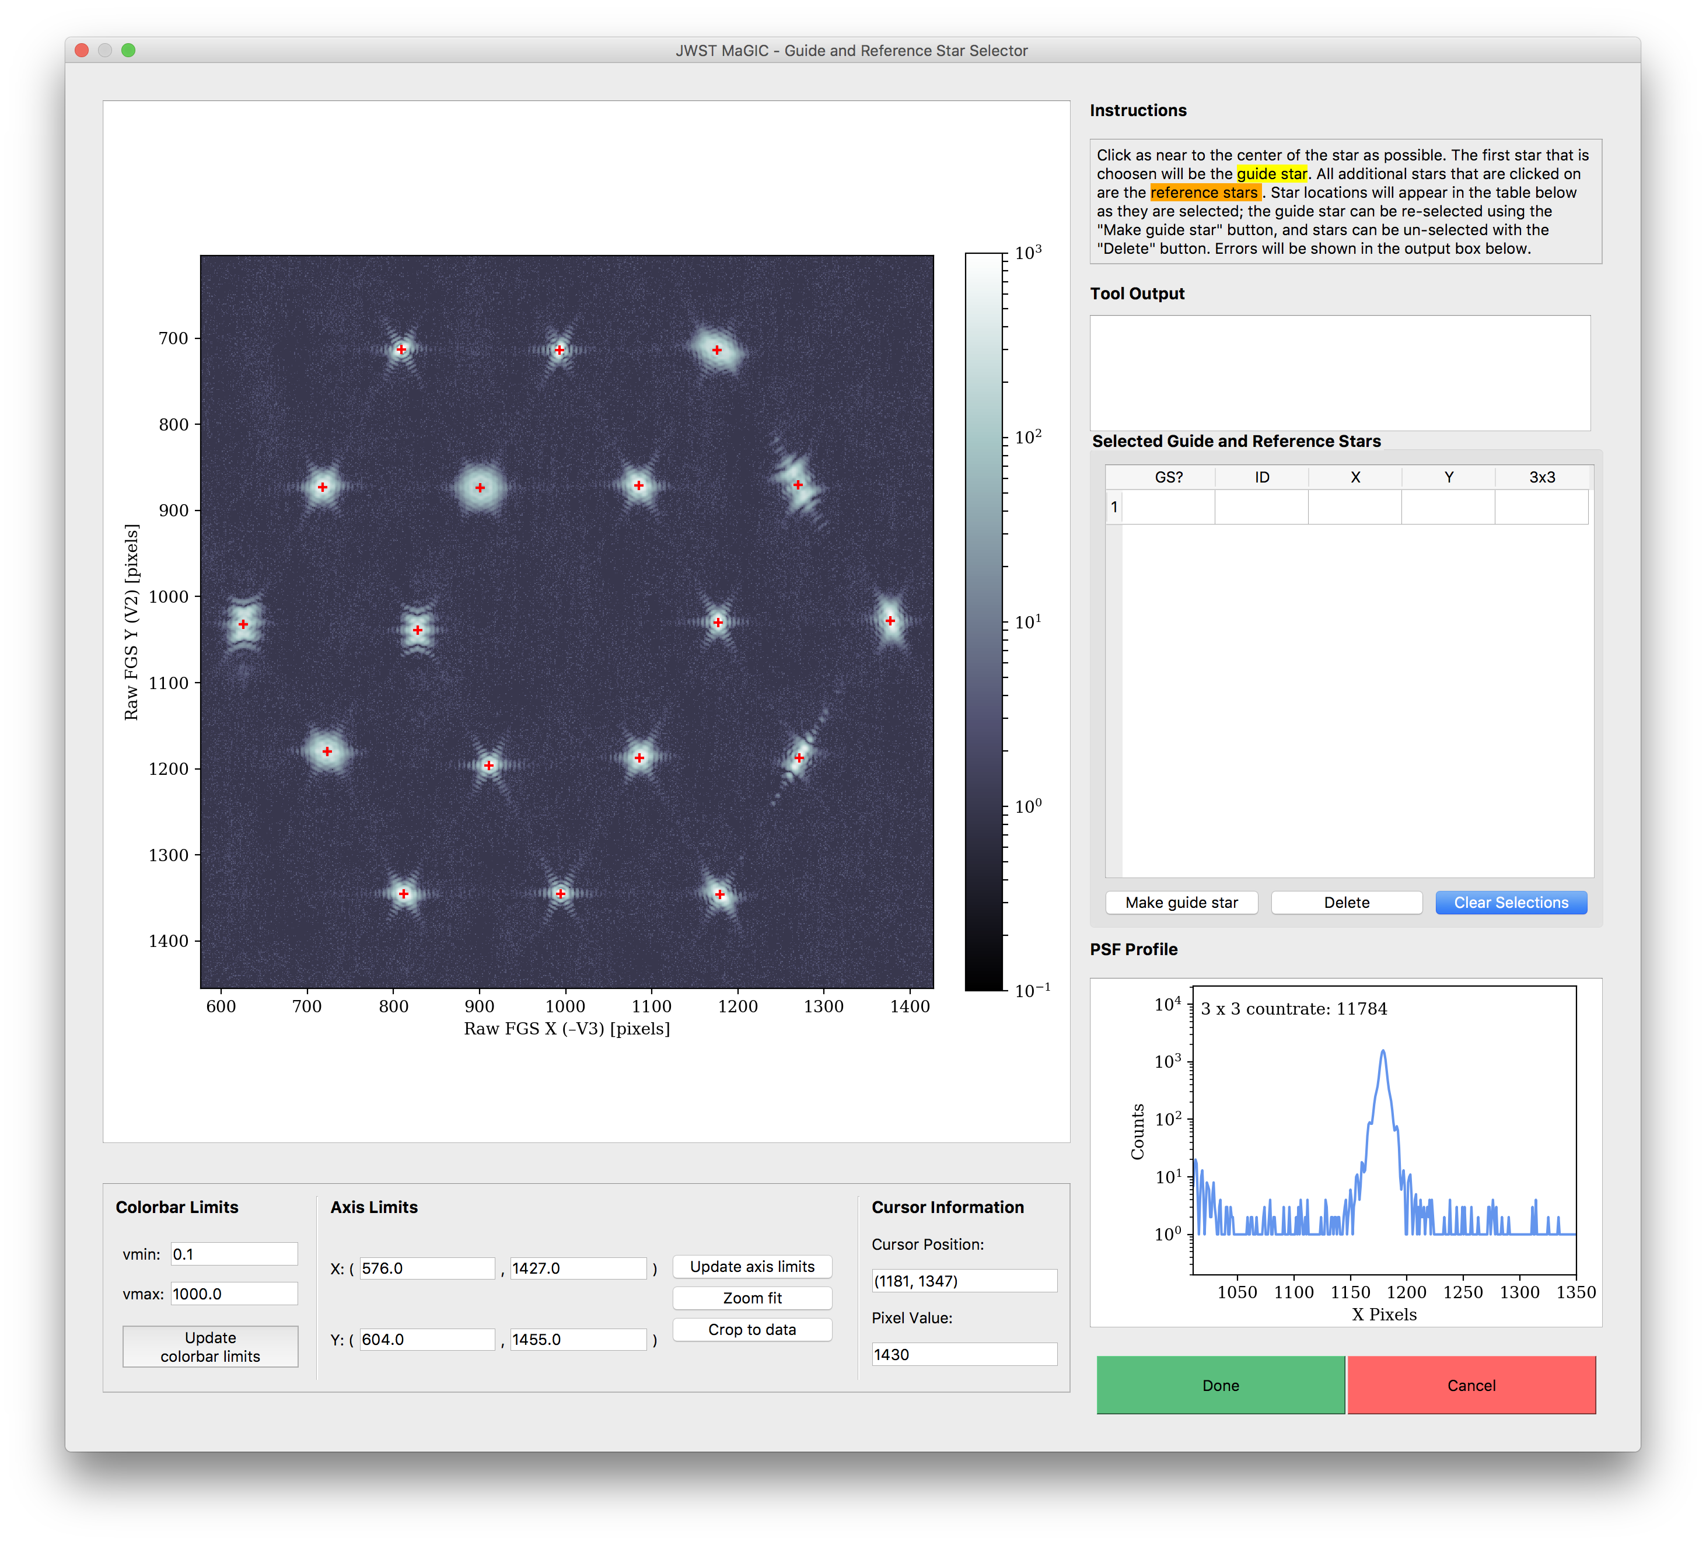

**C**

**B**

**A**

Figure - Star Selection GUI window

* 1. Inspect the PSFs in the image by moving your cursor over different PSFs. Examine the profile plot to see the distribution of light.
  2. Select, by clicking, which PSFs will be the guide star and the reference stars. The first star selected will be the guide star, while any subsequent stars will be reference stars.

*See* *Appendix D* *to choose the guide and reference stars based on the mirror state.*

* 1. If you want to change your selections while in the tool, use the **“Make Guide Star”** **A**  button to change the guide star, use the **“Delete”** button **B**  to remove individual selections, and use the **“Clear Selections”** button **C**  to start over.
  2. When you are happy with your selections, click “Done”

The output files will be located in the specified out directory.

# Testing Selections in DHAS

After selecting the guide and reference stars, we have to determine whether or not this selection will be successful with the flight software (FSW). To do this, we can use the files created in the last section to run our images through the FSW simulator, the FGS Data Handling Analysis System (DHAS).

*Note:* Don’t close the MAGIC GUI while you are working in DHAS; you will need to use that open MAGIC window later.



Figure : DHAS GUI

1. Load the IDstrips.fits file you just created:
   1. Click the blue “Load Multiple .FITS Files” button



* 1. Using the “Current Directory” drop-down menu (or by typing the path directly into the textbox), navigate to the out/{root} directory where the images have been saved
  2. Go the “dhas” subdirectory
  3. Check the “Show All Files” box
  4. Select the IDstrips.FITS file (In the above example, GA_obs1_WFR_G1_IDstrips.fits)
  5. Click “Add →”
  6. Click “Done”

1. Add the Bad Pixel Map
   1. Check the “Apply Bad Pixel Map?” box above the “Load Multiple .FITS Files” button (see figure above)
   2. In the finder window that opens, choose the most recent bad pixel map (check the “rev” number on files with a .pix extention). For DHAS verson 3.0, this file is G1_F11_CV3_Rev_63.pix for guider 1 and G2_F14_CV3_Rev_63.pix for guider 2.
   3. Click “Open”
   4. In the “Image Size Mismatch…” dialog box, click “OK” (the default settings are correct).
2. Run the ID simulator. (DHAS can also be used to simulate ACQ and TRK, but for brevity’s sake we will just check that ID is successful.)
   1. Click the corresponding G1 or G2 button depending on if this is a guider 1 vs. guider 2 image at the top of the page



* 1. Click the small pink “ID-sim” button at the top of the page



* 1. A finder window will appear with the expectation that the user will choose the appropriate .prc file (no text indicates this). For this step (ID) open the ID.prc file corresponding to the IDstrips.fits file that you selected (in the above example, GA_obs1_WFR_G1_ID.prc)
  2. When the star_catalog_page dialog box appears:
     1. Set the Row and Column values to be 12 and 0 (in the bottom left corner of the window), respectively (the X-Angle and Y-Angle values will automatically change to reflect this):



* + 1. If you want to alter your guide & reference star selections, do so here by toggling the “GS” (guide star) and “RS” (reference star) buttons
    2. Click the “Done” button.
  1. When the ID Mode Setup dialog box appears, click “OK.”

1. Wait for the simulator to run
2. When the finder window pops up, press “Cancel”
3. DHAS results: Commanded (CMD) reference stars are denoted by yellow triangles (∆). The commanded (CMD) guide star is denoted by a yellow cross/plus sign (+). The reference stars that the DHAS has found are denoted by blue x’s (x) and the guide star is denoted by a blue asterisk (*). See the screen shot below for an example of a successful DHAS run.



Figure : Example of a successful DHAS run

1. Inspect the DHAS results
   1. Do the stars that DHAS found (in blue) match the stars you commanded it to find (in yellow) If not, DHAS has **failed**.
   2. For more detailed DHAS diagnosis:
      1. Does DHAS think it successfully found the guide star? (Does “Status” equal SUCCESS?)
      2. Did DHAS find all of the stars? (Does “# Candidates” equal 18 – for GA or image array steps?)
      3. If necessary, click the “Export” button to more closely examine DHAS’s output plot and/or save the image as a .PNG
2. If all goes well, click the “EXIT” button in the DHAS GUI to exit the GUI and then type “exit” into the Command Window to close MATLAB JWQL presentation prep
3. When: Wednesday, March 13, 2019 at 9:45 AM - 11:00 AM.
4. Location:

If DHAS fails, we need to try a different orientation of guide and reference stars until we find a successful one. Continue to section VI.

If DHAS succeeds, continue to section VII or section VIII.

# Contingency: Re-selecting Stars and Re-running DHAS

When re-selecting stars for testing in the DHAS, not all of the files generated by the commissioning tools need to be rewritten; only the files that specify which segments are the guide star and reference stars need to be changed (namely, the ID.prc and regfile.txt files). Thus, though completely re-running the tool would work to re-select the guide and reference star segments (see section IV), it is not necessary. We have developed a faster method for re-selection and file rewriting, detailed here:

1. In the main GUI, select the “Only write…” button within the Flight Software File Writer box. All other options in the interface will be disabled.

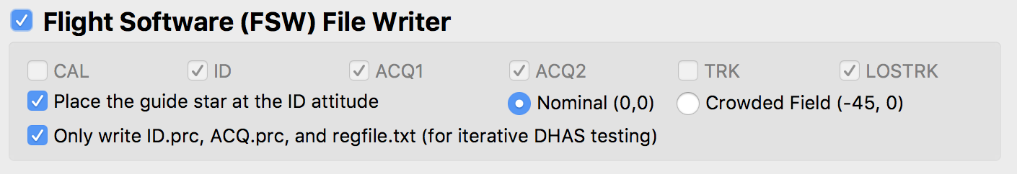

Figure - Flight Software file writer section of the Main GUI for the case when only the .prc files are over written

1. Run the tool:



1. When the Star Selection GUI appears, again examine your input image.

*Note:* If you prefer to analyze the image in DS9, you can do so by typing $ ds9 name_of_image.fits into the command line or !ds9 name_of_image.fits in IPython. Be sure to load the image in the …/FGS_imgs/ directory, which is your FGS image. Since DS9 displays images differently than Python, go to the Zoom menu in the menu bar of DS9 and select “Invert Y”.

1. Select new guide/reference stars and click “Done”.

*See* *Appendix D* *to choose the guide and reference star based on the mirror state.*

This step will overwrite the existing ID.prc and regfile.txt files with the new star commands.

1. Re-run DHAS (section V)

If DHAS fails again, we still need to try a different orientation of guide and reference stars until we find a successful one. Repeat section VI.

If DHAS suceeds, continue to section VII or section VIII.

# Writing the Segment Override File (SOF)

Another very important part of MAGIC is creating the override file that can be used to override the way guide and reference stars are selelcted by the GSSS. This file only has to be created when using MAGIc for commissioning activities and their rehearsals where the segments of JWST’s primary mirror are unstacked. In that case we use the PSFs created by each segment as our guide and reference stars.

1. In the main GUI, select the “Segment Guiding” box. All other options in the interface will be disabled.

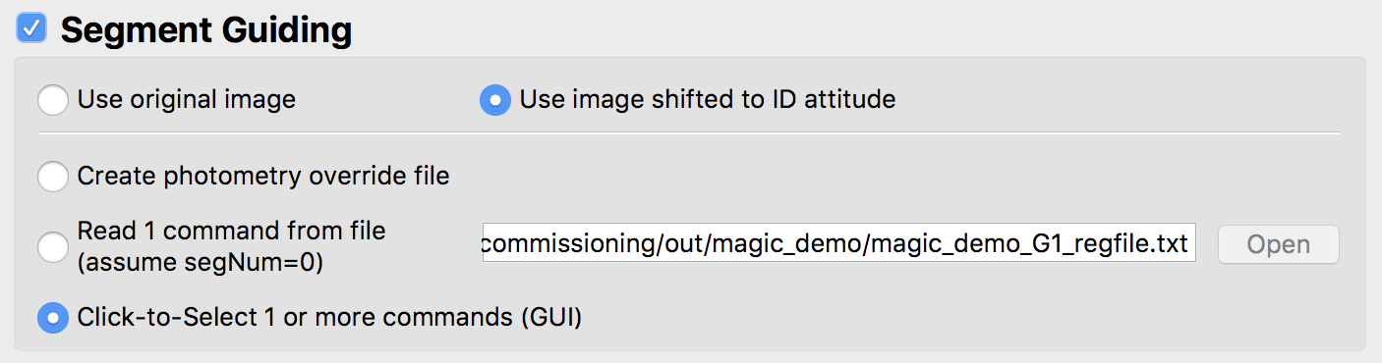

**D**

**C**

**B**

**A**

Figure - Segment Guiding Section of the Main GUI

1. If the image has been shifted so the guide star is at the ID attitude, use the **radio buttons A**  to designate whether to generate the override file using the original (unshifted) image or using the shifted image.
2. Determine whether to generate an override file from an existing file or using the click-to-select GUI:
   1. If creating a photometry override file using the **“Create photometry override file” radio button B**  , see section VIII below.
   2. If creating an override file for a visit where the mirrors are in an array and you wish to use the *same* guide and reference stars from section III, select the **“Read 1 command from file” radio button** **C**  and don’t change the auto-populated segment guiding filepath. This creates the segment override file so that it only uses the guide and reference stars selected by the user in step III and will bypass the override file creation using the Segment Guiding GUI. If making this selection, skip to step 6 below.
   3. If creating an override file for a visit where the mirrors are in an array and you wish to use *different* guide and reference stars from section III that are specified in a different file (most likely a regfile.txt or a .incat file), select the **“Read 1 command from file” radio button** **C** a and specify the path to this file. Providing this file will create the segment override file so that it only uses the guide and reference stars selected by the user in step III and will bypass the override file creation using the Segment Guiding GUI. Once this file is selected, skip to step 6 below.
   4. Otherwise, select the **“Click-to-Select 1 or more commands (GUI)” radio button** **D**  to launch the GUI that will allow you to click-to-select multiple orientations of guide and reference stars.
3. 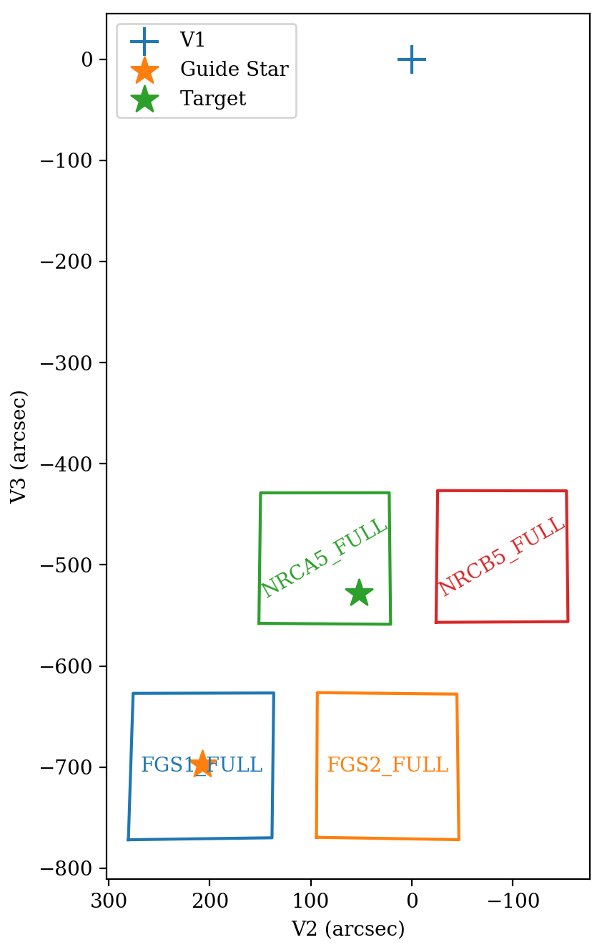Before running the tool, obtain the following parameters with the following methods:
   1. **APT parameters**: If you do not know, ask the Wavefront Ops for the program ID, observation number, and the visit number.
   2. Guide star **RA** & **Dec**: Retrieve the guide star ID from the APT file (see Appendix C for a step-by-step guide for doing this). Go to the Guide Star Catalog webform ([http://gsss.stsci.edu/webservices/GSC2/  
      WebForm.aspx](http://gsss.stsci.edu/webservices/GSC2/WebForm.aspx)), and query with the guide star ID in the “HST ID” field to determine the RA and Dec.
   3. **Position Angle**: Ask the S&OC for the visit position angle at the guide star (V3PA@GS).

*See the figure at right to clarify the difference between V1, the target, and the guide star.*

* 1. Get the current **V2 & V3 boresight offset** from the Wavefront Ops.

1. Run the tool:



Figure 14 – Locations of V1, the guide star, and the target

1. 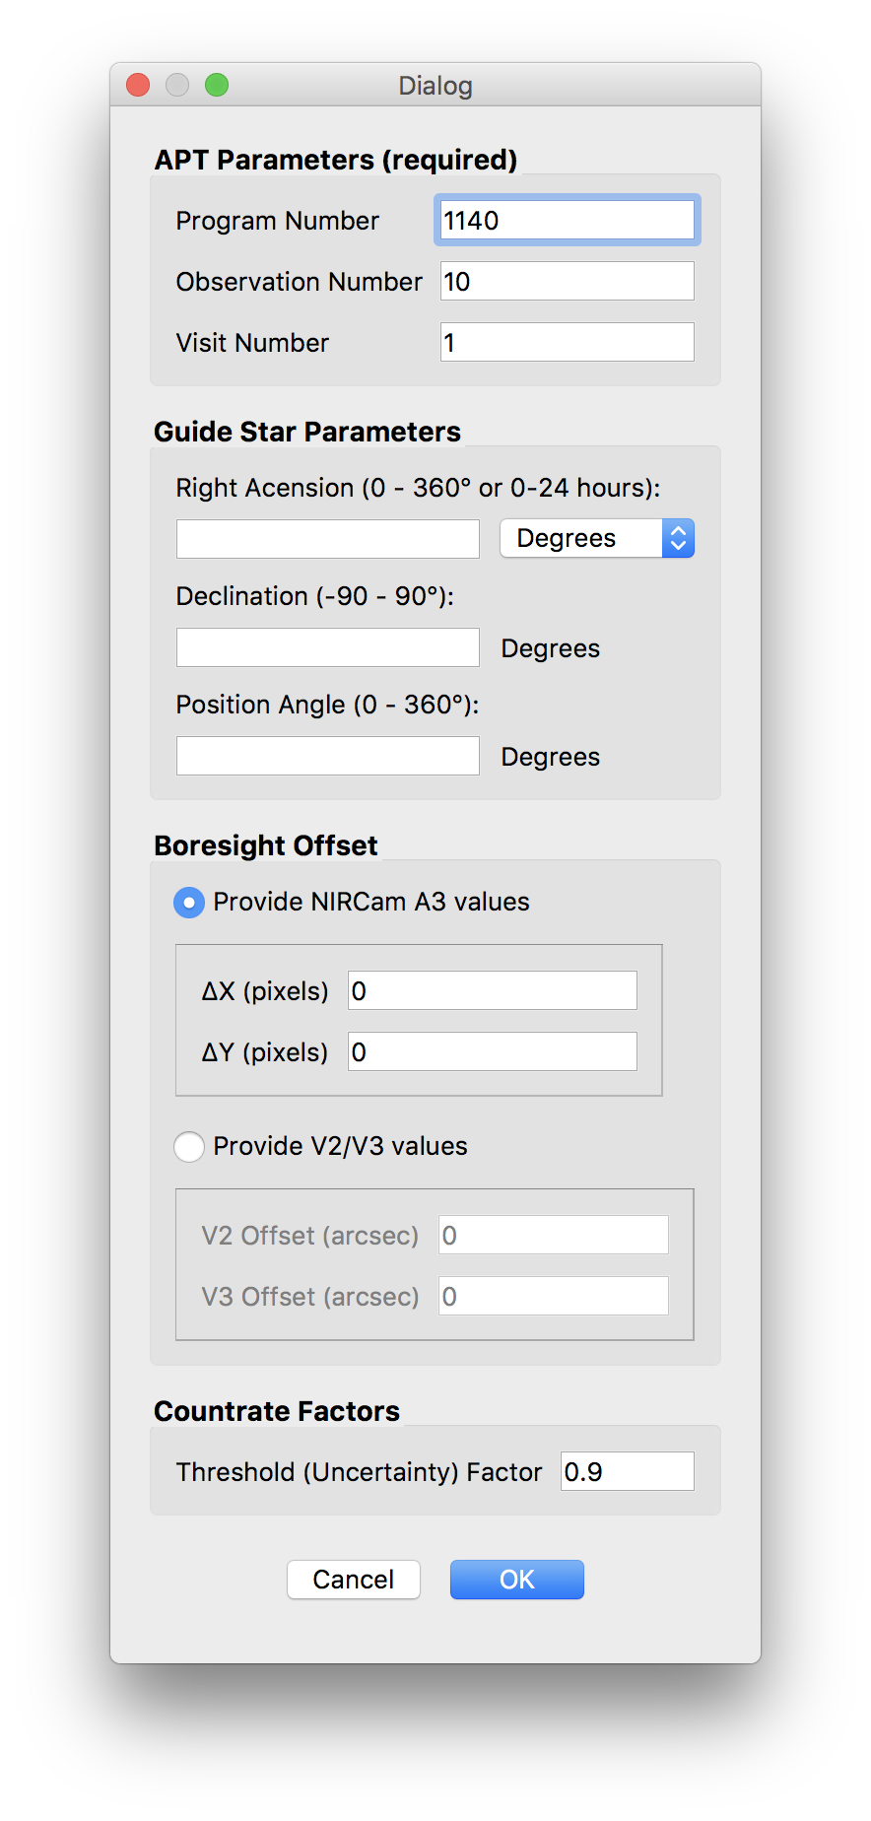When the Segment Guiding Dialog Box appears (shown at right), define the segment guiding parameters, including:
   1. **Program Number** – ID of the current APT program; three to five digits
   2. **Observation Number**
   3. **Visit Number**
   4. **Right Ascension** *(optional)* of the guide star
   5. **Declination** *(optional)* of the guide star
   6. **Position Angle** of the observatory at the guide star at the time of the visit
   7. **V2 Boresight offset** *(optional)*
   8. **V3 boresight offset** *(optional)*
   9. **Uncertainty factor** *(optional)* – the degree of uncertainty in the countrate of each segment. e.g., an uncertainty factor of 0.9 for a star with a countrate of 1,000 writes an uncertainty of 900.
2. Click “OK” to continue.

Figure 15 - Segment Guiding Dialog Box

When the Segment Guiding GUI appears:

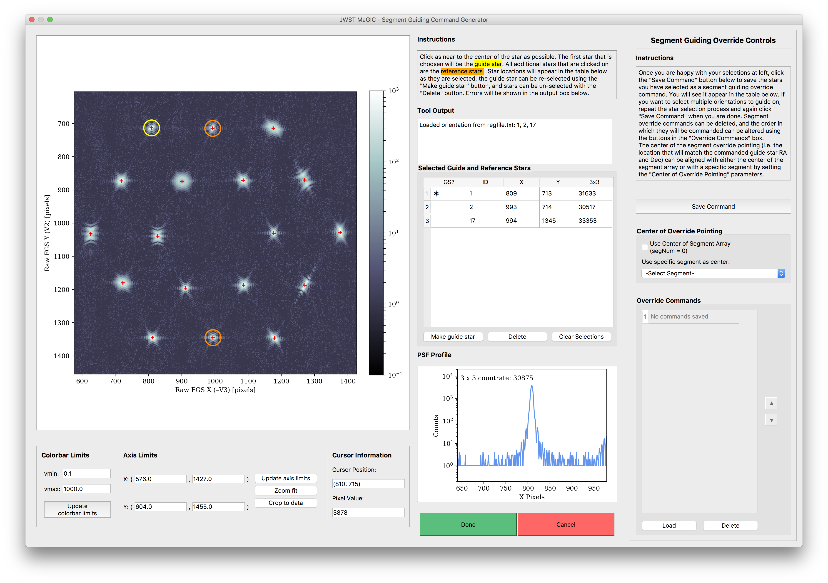

**F**

**E**

**D**

**A**

**B**

**C**

Figure 16 - Segment Guiding GUI Window

1. Repeat the steps outlined in Part III to select the guide and reference stars – the ones that you verified were successful with DHAS – for one segment guiding override command.
2. When you are happy with your selections, click the **“Save Command” button**. **A**  You will see the IDs of the stars you selected appear in the **“Override Commands”** table **C** .
3. To add another command, again repeat the steps outlined in Part III to select guide and reference stars, and again click the **“Save Command” button**. **A**  d
4. To change the order of the commands, use the **up and down arrow buttons**. **D**  To view a saved command on the plot, click the **“Load” button**. **E**  To remove a command from the list, click the **“Delete” button**. **A**  d
5. Select the **center of override pointing**. **B**  This sets the origin of the ideal frame (i.e. the location of the guide star if the segments were stacked). It can either be set as the center of the segment array, using the “Use Center of Segment Array” checkbox, or the location of a specific segment using the dropdown box.

*See* *Appendix D* *for more about selecting the center of override pointing based on the mirror state.*

# Writing the Photometry Override File (POF)

In the case of MIMF where we only need to change the photometry of the guide star (the RA and Dec and expected count rates are taken from the APT file), we need to make an override for Planning & Scheduling but this is for the photometry and will have no information about the segments (because the PSFs from the individual segments are stacked).

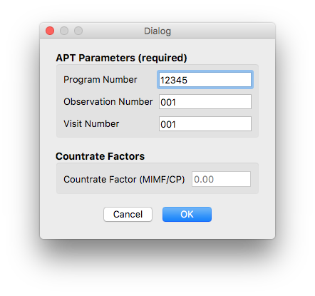

Creating a photometry override file through MAGIC:

* + - 1. Load the file for this observation, select the guider, the set the out directory and root.
      2. As in section VII, in the main GUI, select the “Segment Guiding” check box. All other options in the interface will be disabled. Note: You do not need to run the other parts of MAGIC when creating a photometry override file.
      3. Select the **“Create photometry override file” radio button** ( **A** in figure 11 above)
      4. Run the tool.
      5. When the Segment Guiding Dialog box opens, fill in the Program ID, Observation Number, and Visit Number just as you would for creating a segment override file. Additionally, you can add the **countrate factor**:

Figure 17 - Photometry Override Dialog Box

**Countrate factor**: A factor between 0 and 1 that all countrates and thresholds are to be multiplied by. This factor is used for cases such as MIMF and CP when the segments are stacked but unphased, and so the brightness of the guide star is dimmed.

*See* *Appendix D* *for information about the countrate factor based on the mirror state.*

* + - 1. Click “OK”

## Creating a photometry override file in IPython:

Alternatively, in the case of having to create multiple photometery override files, this can be done in IPython with a for loop.

* **root** – the root name that will be used for the observation. This has to do with where files are saved so consistency is important
* **program_id** – ID of the current APT program; three to five digits
* **observation_num** – the observation number for this observation
* **visit_num** – the visit number for this visit
* **countrate_factor** –factor by which to multiply all countrates and thresholds
* **out_dir** – path to the out directory where all files will be saved

In [1]: from jwst_magic.segment_guiding import segment_guiding

In [2]: root = ‘root’ #Root used for this dataset

In [3]: program_id = 12345 #Program ID - int

In [4]: observation_num = [1, 3, 4, 5, 7] #List of Observation numbers

In [5]: visit_num = [1, 1, 1, 2, 1, 1] #List of Visit numbers

In [6]: countrate_factor = 0.6 #Float between 0.0 and 1.0

In [7]: out_dir = ‘/path/to/out/directory’

In [7]: for i, (o, v) in enumerate(zip(observation_num, visit_num)):

segment_guiding.run_tool(root=root, program_id=program_id,

observation_num=o, visit_num=v, countrate_factor= countrate_factor, out_dir=out_dir)

# Appendix A: Installing the JWST MAGIC Package

This section is only if you are install MAGIC on your own machine. For SOGS, you will have to follow the [instructions on the JWST ITAR Wiki](https://jwstitarwiki.stsci.edu/pages/viewpage.action?spaceKey=WFSCOWG&title=WF+Guiding%3A+Set+up+personal+SOGS+environment).

1. Activate your astroconda (Python 3) environment. For installing astroconda see: <http://stsci-env.readthedocs.io/en/latest/installing_anaconda.html>
2. $ cd into the directory where you want to keep the package.
3. Clone the tools from the grit repository:

$ git clone git@grit.stsci.edu:wfsc/tools.git

1. Install the jwst_magic package:

$ cd tools/fgs-commissioning

$ pip install -e .

The package installation process will also check for the following package dependencies, and automatically install them using pip if they are not found:

* + - astropy
    - matplotlib
    - numpy
    - photutils
    - PyQt5
    - pysiaf
    - pytest
    - pyyaml
    - requests

# Appendix B: Setting Up DHAS

1. If you are working on SOGS and you have not already configured DHAS to work on your personal SOGS account, follow the [instructions on Innerspace](https://innerspace.stsci.edu/display/INSTEL/Setting+up+the+DHAS+on+your+SOGS+account) for setting DHAS up correctly on SOGS.
2. Find the MATLAB icon on the dock and double click to open MATLAB (or press CMD + space to open Spotlight and search for MATLAB)
3. In the MATLAB interface, if not already there, navigate to the DHAS, version 3.0 directory

$ cd /Users/<username>/Documents/MATLAB/dhas/v3.0/fitsdisp2_v3p0/

1. Start the DHAS GUI:

$ fitsdisp2

# Appendix C: Using APT to Get Guide Star RA & Dec

1. Open APT
2. Load the APT file for the current program:
   1. File > Retreive from STScI > Retreive using Proposal ID…
   2. Enter the proposal number (e.g. 1141 for Global Alignment). If you’re not sure of the number, check out this [table of proposals](http://www.stsci.edu/ops/jwst-pit-status.html).
3. Using the navigation panel at left, navigate to the “Observations” folder, open the desired observation folder, and look at the form editor for the desired observation. The observation forms are the ones that have (Obs #) in their name.
4. Click the “Special Requirements” tab
5. If the observation is a NIRCam observation (“Instrument” is NIRCAM or WFSC):
   1. If there is a special requirement called “Guide Star ID”:
      1. Take note of that ID (e.g. N13I018276)
      2. Query for this guide star using the Guide Star Catalog webform (<http://gsss.stsci.edu/webservices/GSC2/WebForm.aspx>), inputting that ID as the HST ID
      3. Copy the RA and Dec from the web results
   2. If there is no “Guide Star ID” special requirement and there is a requirement that states “PCS Mode COARSE”, then that observation is taking place in coarse pointing mode and guiding will not be involved. Ask yourself why you are doing this in the first place.
   3. If there is no “Guide Star ID” special requirement and guiding is taking place, it is not possible to get the guide star from this APT file. Talk to Ed Nelan ([nelan@stsci.edu](mailto:nelan@stsci.edu)).
6. If the observation is an FGS observation:
   1. If there is a special requirement called “Fiducial Point Override” that specifies a NIRCam aperture, it is not possible to get the guide star from this APT file. Talk to Ed Nelan ([nelan@stsci.edu](mailto:nelan@stsci.edu)).
   2. Otherwise, take note of the number and name of the target for this observation.
   3. Using the navigation panel at left, navigate to the “Targets” folder, open the “Fixed Targets” folder, and look at the form editor for the selected target.
   4. Copy the RA and Dec of this star

# Appendix D: Mirror State Procedures

*Modified from Appendix D in the OTE CAR procedures.*

|  |  |  |  |
| --- | --- | --- | --- |
| Mirror State | Guide and Reference Star Selection Criteria | Center of Pointing | Countrate Factor |
| Image Array (large or small) | *Guide Star*:   * Choose the PSF with the most compact shape and sharpest peak.   *Reference Stars*:   * Choose two (2) reference PSFs, preferably on the outer ring of the image array, that are as compact as possible. Be sure that the distances between selected PSFs are unique (a good idea is to choose one star close to the guide star and one that is far away). | The center of the image array | N/A |
| Small Image Array with one PSF kicked out | *Guide Star*:   * Choose the PSF that has been kicked out.   *Reference Stars:*   * Choose two (2) reference PSFs, preferably on the outer ring of the image array, that are as compact as possible. Be sure that the distances between selected PSFs are unique (a good idea is to choose one star close to the guide star and one that is far away). | The center of the image array | N/A |
| Stacked PSFs with one kicked out | *Guide Star:*   * Choose the PSF that has been kicked out.   *Reference Stars:*   * Stacked PSFs | The stacked PSF | N/A |
| Stacked PSFs | *Guide Star*:   * N/A   *Reference Stars*:   * N/A | N/A | Image Stacking/Coarse Phasing: 0.1*  MIMF: 0.001  *These values are a guess and will be updated in the future |